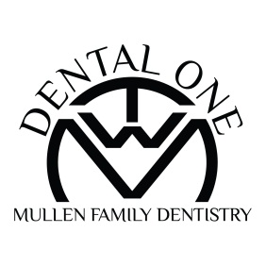
Dental One
Dental Savings Plan Application

Effective Date:_____________
Last Name:_____________________________First Name:__________________________MI:_________
Home Address:____________________________________City______________State___Zipcode______

Covered Plan Members:
Name | Birth Date | Relationship | Plan (circle one)
 | / / | Initial Member | Traditional/Periodontal
 | / / | Additional Member | Traditional/Periodontal
 | / / | Additional Member | Traditional/Periodontal
 | / / | Additional Member | Traditional/Periodontal
 | / / | Additional Member | Traditional/Periodontal
 | / / | Additional Member | Traditional/Periodontal

Traditional Plan Periodontal Maintenance Plan
Initial Family Member - $365 Initial Family Member -$620
Each Additional Family Member - $340 Each Additional Family Member - $595

Payment Method
- Check
- Cash
- Debit/Credit Card #_______________________________Exp Date_____________CVC________
- Care Credit #____________________________________Exp Date_____________CVC________

By signing below, I acknowledge that I have read the brochure and understand the plan details and limitations.
Signature____________________________________ Date____________________________
(Signature of plan holder)

I authorize Dental One to charge my credit card each year upon my anniversary date to automatically renew my enrollment in the discount Plan. Dental One will notify me when the plan is renewed for my record. If I choose to discontinue participating in the discount plan, I will notify Dental One one month prior to my anniversary renewal date.
Signature____________________________________ Date____________________________
(Signature of plan holder)

*Annual fee is required at enrollment and is non-refundable. Dental One reserves the right to modify, change, or discontinue the In-office Dental Savings Plan, fees, term, and services at the company’s option upon written notice from Dental One prior to your Anniversary renewal date.

